PLTC WELFARE OFFICER
We take Child Protection at PLTC very seriously.
All our coaches have recent Disclosure and Barring Service (DBS, previously CRB) checks. It is our policy that the Club Manager and Head Coach will check each coach’s LTA Registration every six months and keep a record of when each coach’s DBS expires.
David Halls (Club Manager) is our Welfare Officer and Tim Haynes (F&B Manager) will act as our 2nd Welfare Officer in David’s absence. Their roles are to ensure that our Child Protection (Safeguarding) policy is implemented and promoted and that the club follows best practice in safeguarding and includes receiving and acting on any reported child protection concerns, whether they come from members of the club or members of the public.
Please do speak to David or Tim if you would like to discuss any child protection concerns or have any suggestions about how we can make the club safer for our young players and vulnerable members. Alternatively, please get in touch by phone or email as below. David is not at the club on Thursdays or Fridays.
A copy of David’s Safeguarding Certificate is available for view on request.

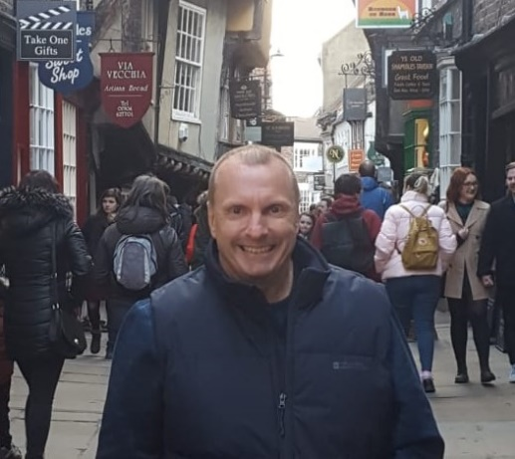 | David’s contact details:  Mobile: 07956 354456  email: djhalls68@gmail.com  Tim’s contact details:  Mobile: 07956 986968  email: fbmanager@pltc.co.uk

